
Eaglehawk Neck, Tasmania
Thursday 25th , Friday 26th & Saturday 27th April 2024
Conducted by the Tuna Club of Tasmania Inc.

TGFA Sanctioned Contest
Entry form must be completed and reach the Secretary of the Tuna Club of Tasmania Incorporated with the correct entry fees NO later than Close Of Business ( 5:00pm ) Friday the 19th April 2024, PO Box 507, Sandy Bay, Tas, 7006 or by email to info@tunacluboftasmania.asn.au
The entry fees can be paid EFT from your Bank Account, entry forms must be signed and mailed or emailed.
It is mandatory that you attach a copy of your current marine insurance policy and provide details on this form
By signing this entry form you declare that your vessel carries the required safety equipment detailed on the reverse of this entry form.
Team Members ( min of 2 Anglers max of 6 Anglers that are current financial members of a Club affiliated with GFAA )

Surname Given Name Club Age of Jnr & Small fry anglers
Angler 1
Angler 2
Angler 3
Angler 4
Angler 5
Angler 6
Team Captain :
Vessel Name : Length in metres : Radio Frequency :
Skippers Name :
Skippers Mobile No :

Insurance Company : Policy No : Expr Date : / / 20
Contest Entry Fee: $ 80.00 Per Adult Angler $_ _ _ _ _ _ _ _ _
$ 30.00 Per Junior / Small Fry Angler (Under 16 / 11 as at 25/04/2024) $_ _ _ _ _ _ _ _ _
Late Entry Fee : All entries will be accepted up until COB on 19thApril 2024. Late entries will only be accepted if a 50 boat fleet has not been exceeded by this date and if accepted will incur a $200 late fee. $_ _ _ _ _ _ _ _ _
Breakfast Order Thur, Fri & Sat , Number of egg & bacon rolls each day = if available $ pay on the day
Lufra Dinner limited to 180 guests $ 40.00 per person & $ 25.00 per Child 11 years and under $_ _ _ _ _ _ _ _ _ Meal Numbers : Number of Adults : Number of Juniors : Total $_ _ _ _ _ _
Please make Cheques Payable to : Tuna Club of Tasmania Inc. Mailing Address: P.O. Box 507, SANDY BAY TAS 7006
EFT Payments - CBA Bank – BSB: 067-028 Account No: 10273656
Bank Account Name: Tuna Club - Please Make Reference to “Your Boat Name” -
Please use EFT Record as your official Receipt

Indemnity Form : (All Contest Entrants to Sign)

The Secretary, the Tuna Club of Tasmania Inc.
Please accept our entry for the 30th Australian Bluefin Tuna Contest . I/We agree to the rules as published . In consideration of you accepting Me/Us as a competitor/s or guests , I/We absolve the 30th Australian Bluefin Tuna Contest organiser, officers and members, their staff, executive, volunteers, assistants and concessionaires, any sponsors. Their officers and members, staff, executive, volunteers and concessionaires as such from any liability whatsoever and howsoever arising from my/our involvement (whether on-shore or out at sea and including any liability resulting from the acts or omissions of my/our boat owner/skipper/deckhand or other employees) in the tournament, and I/We indemnify you and agree to keep you indemnified against all claims, damages, costs and losses that may be claimed or awarded against you or that you may suffer resulting from injury or loss to us or my property of mine/ours invites, or licensees or guests . No nomination form will be accepted until all team participants have signed this indemnity and complete such details on the nomination form . Should any nomination form be accepted prior to such completion and signature, the nomination is subjected to signature of this indemnity and completion of details on this nomination form as and when requested by the Tuna Club of Tasmania Inc. I/We consent to Clubs verifying my membership status .

SIGNED .................................................../................................................................./.............................................................

................................................................./................................................................./............................................................

…............................................................../................................................................./.............................................................
Dated : / / 2024 ><//”>

The following table sets out the minimum requirements for owners and operators of motor-propelled recreational vessels.
Offshore Safety Equipment Requirements
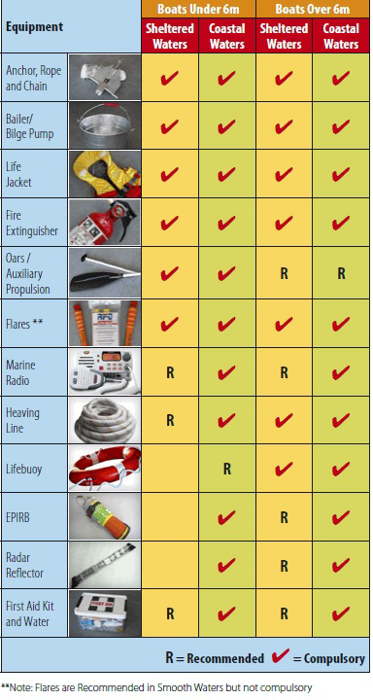

All vessel operating at night require navigational lights or torch
It is recommended that vessels less than 6 metres should not proceed beyond sheltered waters
Shelltered waters are all waters not exceeding 2 nautical miles seaward of land on the north and east coasts unless specified in the MAST “ Limits of Operational Areas “
Please refer to www.mast.tas.gov.au for more information on safety equipment if more detail is required.

If you haven’t recently or are new to Comp fishing , please fill out this Vessel Detail Form

The Tuna Club of Tasmania Inc.

 2023 / 2024 VESSEL DETAILS FORM
Boat Owners Name : ......................................................................................................................
Address....................................................................................................................................................................................................................................................................Post Code………….
Home Phone......................................................Mobile...................................................................
Email: ..............................................................................................................................................
Boat Name : ……………………………………………… Registration No……………….
Make……………………..……… Type eg Half cabin / fly bridge, etc ….............................................
Length of boat is .…..…… Feet or ….……. Metres / Age of Hull...........................................
Hull Construction........................ Hull Colour.…......... Superstructure Colour ……...…..…..
Marine Radio Frequencies Installed :
(Tick) : VHF…. 27 MHz…. HF…. Radio Call Sign………..…………...… Radar…… Yes / No
Type of Motor : outboard / inboard . Brand............................................ H/P............
Second Motor if applicable . Brand. ........................................... H/P……....
Auxiliary Power Type . Brand............................................ H/P...........
Maximum Speed.........(Knots/Kph) Fuel Type ....................... Fuel Capacity............(Litres)
Motor Vehicle Details :

Make:............................................................ Model.......................................................

Year ................. Colour............................ Registration number................................

Trailer Make........................................ Registration number.................................
Boat Insurance Details :
Company Insured.................................. Policy No......................... Exp Date..........
It is a Tuna Club of Tasmania Inc. requirement that all boats are registered, seaworthy and owners must provide evidence of full comprehensive insurance before they compete in any club competitions or contests. All boats must comply with all minimum safety regulations as outlined by MAST (Marine and Safety Tasmania)

I ...............................................................am the registered Owner/skipper of the above vessel and declare that all the above information is true and correct

30th ABFTC Signed.....................................................................................Date....../....../ 2024

